**Project Report :**

**Intelligent Customer Help Desk with Smart Document Understanding :**

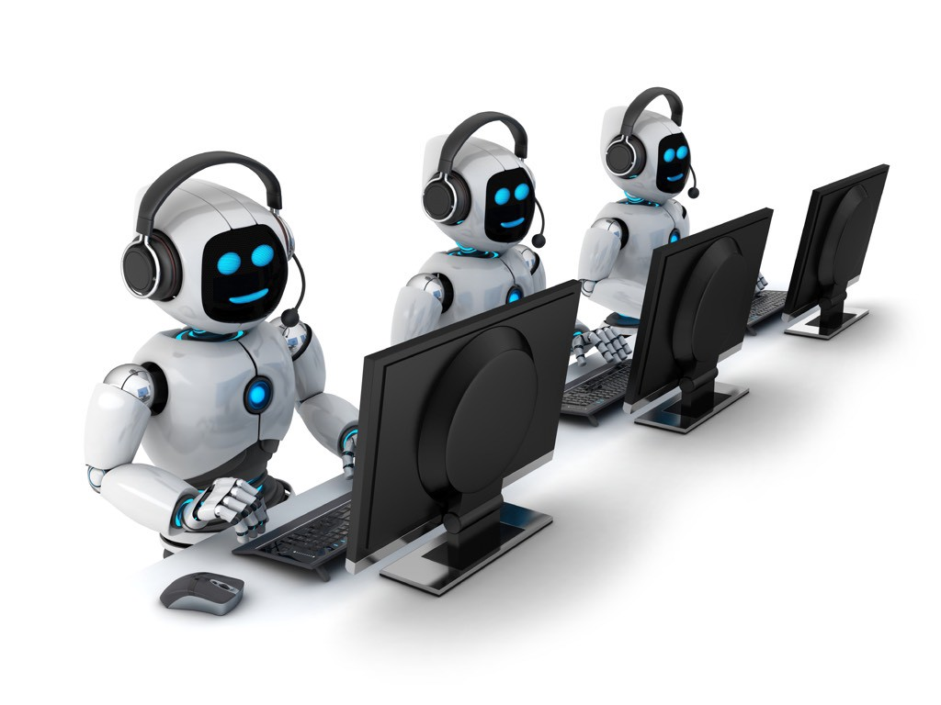

Done By –

P. Roshan Prasad

Email Id : [futurebuddy123@gmail.com](mailto:futurebuddy123@gmail.com)

SB Id : SB20200031742

Under Supervision Of :

Smart Bridge

Appendix :

1. INTRODUCTION

1.1 Overview

1.2 Purpose

1.3 Scope

2. LITERATURE SURVEY

2.1 Existing problem

2.2 Proposed solution

3. THEORITICAL ANALYSIS

3.1 Block diagram

3.2 Hardware / Software designing

4. EXPERIMENTAL INVESTIGATIONS

5. RESULT

6. ADVANTAGES & DISADVANTAGES

7. APPLICATIONS

8. CONCLUSION

9. FUTURE SCOPE

10. BIBILOGRAPHY

Introduction :

#### This is an AI enabled Customer Care chat bot which can make appointments for certain meetings, answer simple questions, get user details, etc.., This chat bot can inserted at the help desks and receptions which acts as a virtual human and also used for automation. This can recognize the user queries and answer the questions however if it fails to recognize the user question it will ask for repeat the question or states as invalid question.

#### In this project, there will be another option. If the customer question is about the operation of a device, the application shall pass the question onto Watson Discovery Service, which has been pre-loaded with the device’s owners manual. So now, instead of “Would you like to speak to a customer representative?” we can return relevant sections of the owners manual to help solve our customers’ problems.

To take it a step further, the project shall use the Smart Document Understanding feature of Watson Discovery to train it on what text in the owners manual is important and what is not. This will improve the answers returned from the queries.

* 1. Overview :

This project reduces the work of help desk by answering the simple queries by the users or clients. This “Smart help desk with smart document understanding” is built via integrating three technologies like IBM Watson Assistant, Node-Red and Watson Discovery. These Three are integrated using cloud function which acts as an API to connect these modules.

IBM Cloud is the Platform which holds all these modules and creates a gateway to build end products. Basically this is an AI enabled chat bot which recognizes the user queries and answer the question based on the certain input. This AI bot understands the query using NLP (Natural Language Processing) and NLU (Natural Language Understanding).

* 1. Purpose :

The most important purpose of this project is to reduce the automation tasks. In the normal method any person is required to answer these repetitive and small queries so, to automate these tasks I have created this AI chat bot which answer the queries of user and replay backs with accurate input.

The Next Important task is to make appointments for the user if he/she is busy with their work. We just have to load all the required document for the tasks to do if user needs to make any appointment for a certain organization or a company.

* 1. Scope:
* Create a customer care dialog skill in Watson Assistant
* Use Smart Document Understanding to build an enhanced Watson Discovery collection
* Create an IBM Cloud Functions web action that allows Watson Assistant to post queries to Watson Discovery
* Build a web application with integration to all these services & deploy the same on IBM Cloud Platform

2. Literature Survey :

Def : A literature survey or a literature review in a project report is that section which shows the various analyses and research made in the field of your interest and the results already published, taking into account the various parameters of the project and the extent of the project.

2.1 Existing System :

In the Existing system the chat bot can answer the questions made by the user but, if any question falls outside the pre-built intent / trained question it doesn’t make any response to the user so, the user won’t be satisfied by the answer and recognize this is a bot.

The main theme of our project is to eliminate the human and create a virtual human and answer all the questions which are asked by the human being. So, this is the biggest disadvantage of the existing system

2.2 Proposed System :

Here I have proposed a system which is enabled by AI and answer all the questions which are asked by the user and replay

Back with an accurate answer. If any question falls out of the trained intents / Question within seconds bot will make a request to the Watson discovery and pulls the answer from the document which we have trained earlier.

Another important part is here no human is needed. Only we have to train the data and it will take care of everything.

This is less expensive and easy to maintainable.

3. Theoretical Analysis :

Theoretical analysis means investigation of problem's decision process methods and peculiarities of the problem description and initial data impact on obtained results. This is the analysis which will give insights for the requirements and statements.

3.1 Block Diagram:

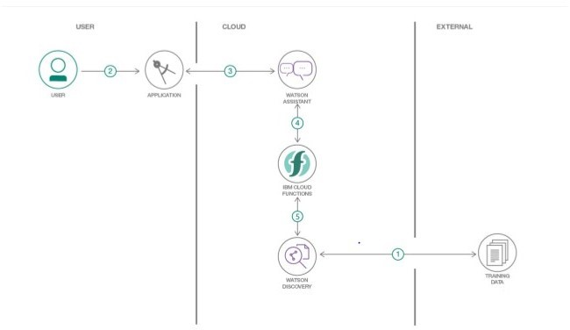

3.2 Software and Hardware Designing:

There are two steps to create this project.

1. Creating IBM Cloud Services:

1. Creating Watson Assistant:

2. Creating Watson Discovery

3. Creating Node-Red Application

4. Creating Cloud function

2. Configuring IBM Cloud Services :

The first important thing is to create the Watson Assistant which provides response to the user queries. Here we will declare the Intents, Entities and Dialog elements to make an interactive conversation. We can try Watson Assistant while creating by clicking on Try button on the top right corner of the page.

The second thing is to create a Watson Discovery and an input dataset (Document) with the required information about the organization. Here we will train the discovery with this document and highlight the titles/ sub-titles based on the requirements and split the document.

The third thing is to integrate these Watson Assistant and Discovery. So, here we are using the cloud function basically the JSON (Java script Object Notation ) file which will make a bridge for these two.

The Final thing is to make a UI (User Interface) that will contain an input field, submit and reset field. Here user has to write their query in the input field and click on submit button. Now, Assistant will recognize the question and gives response.

4. Experimental Investigations :

Watson Assistant :

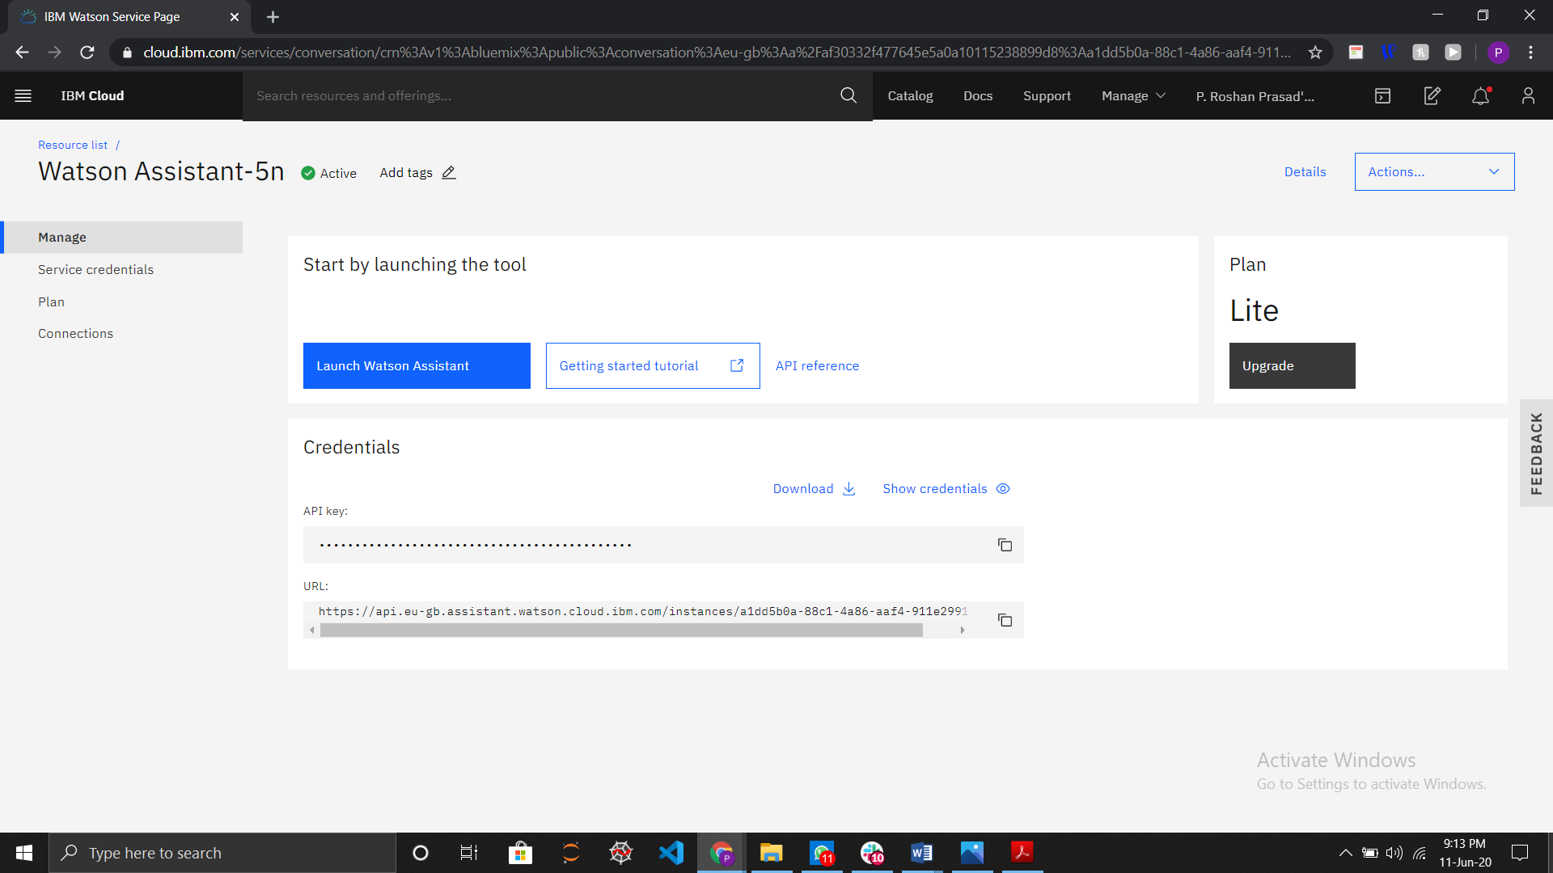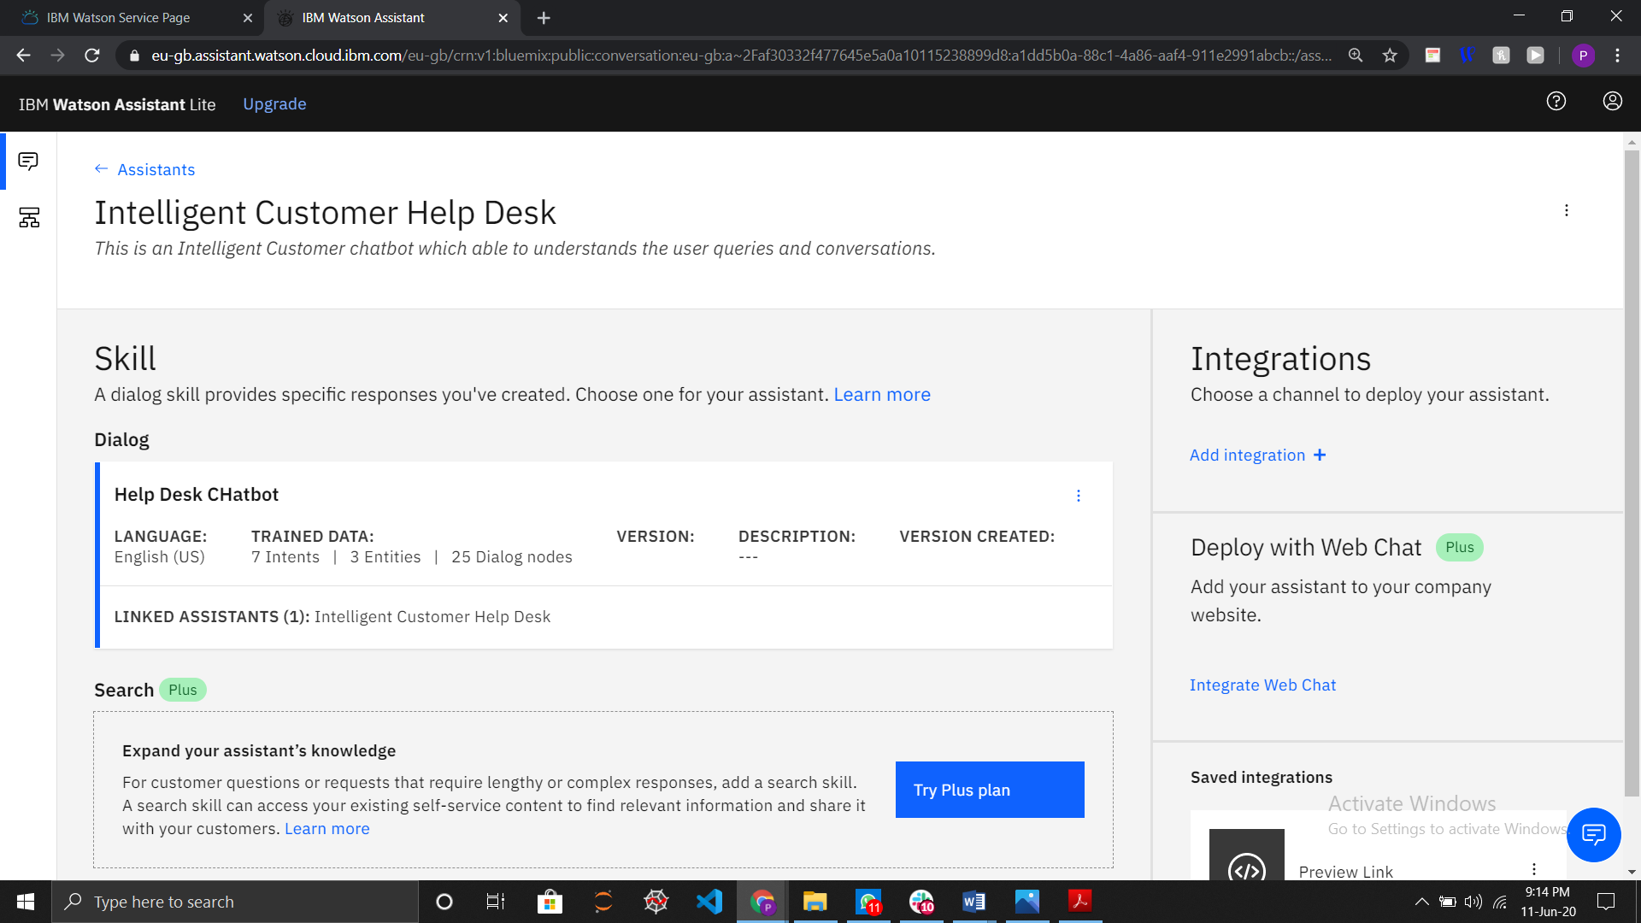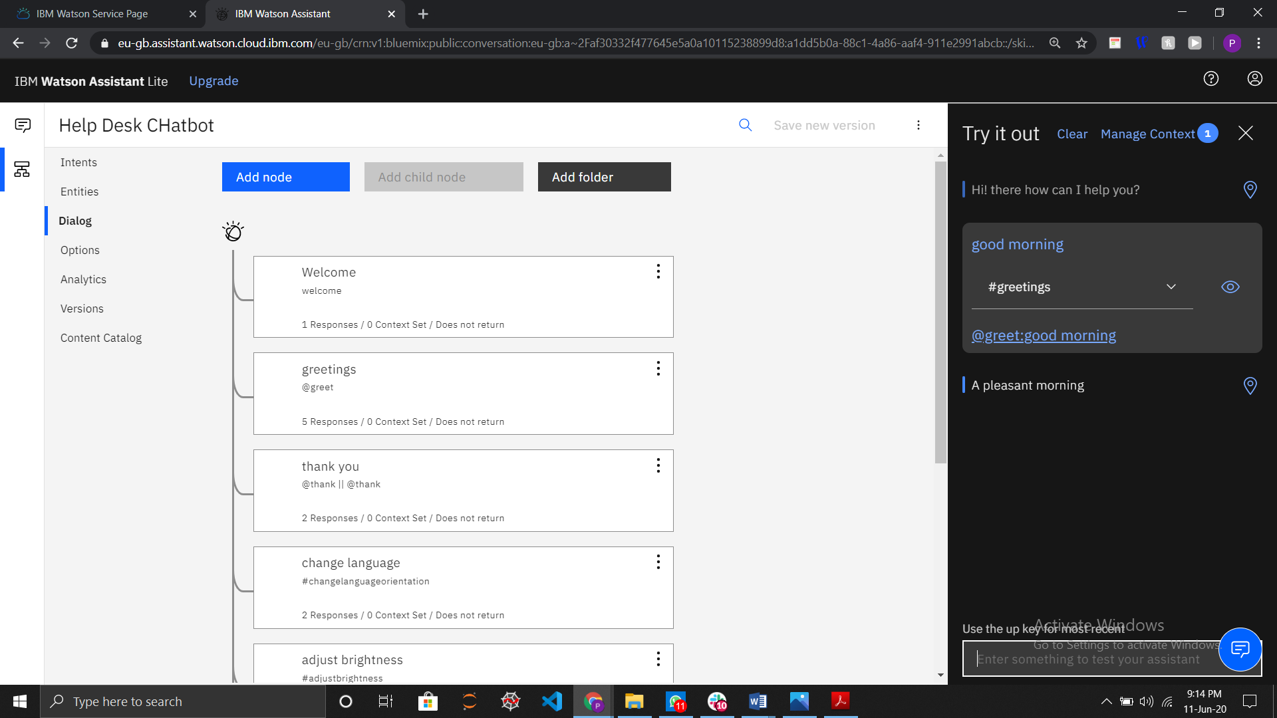

Discovery :

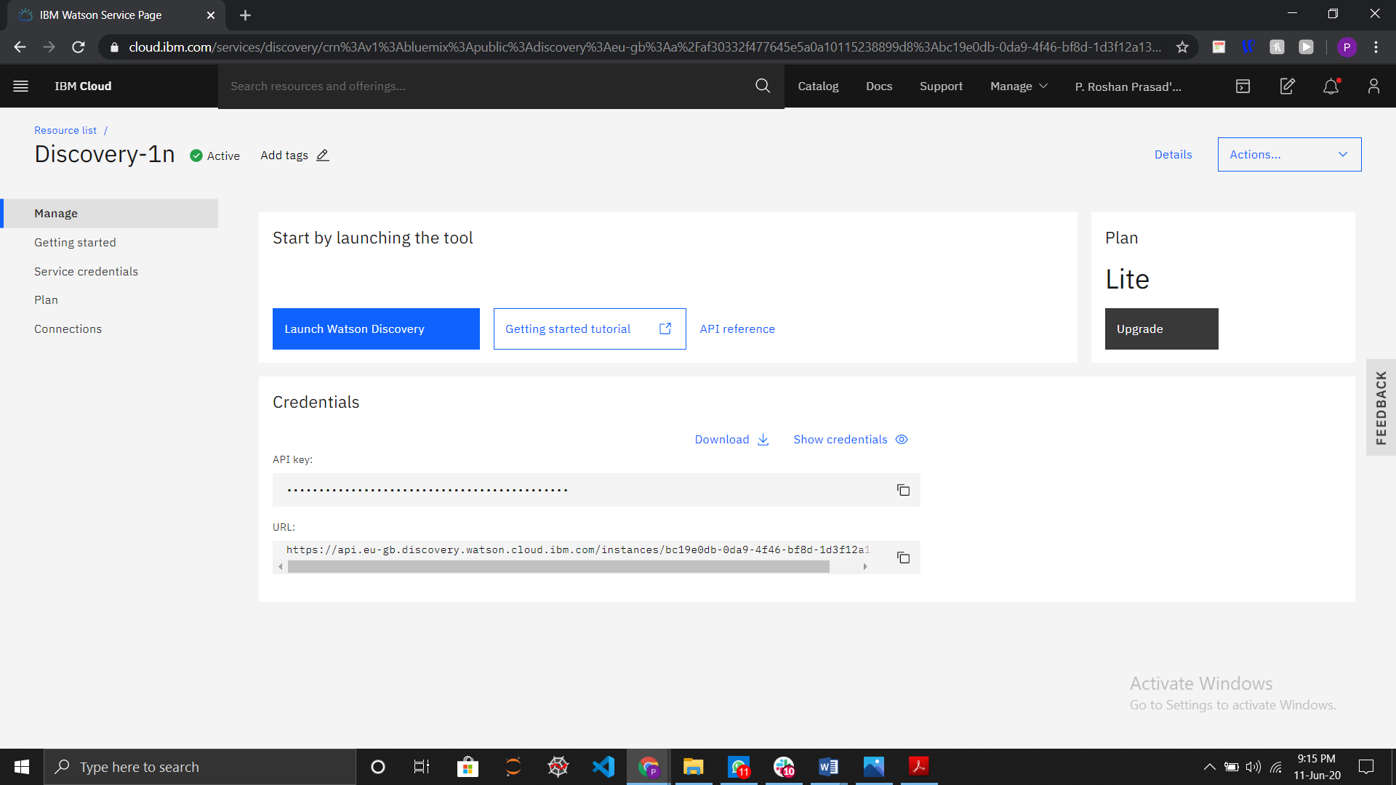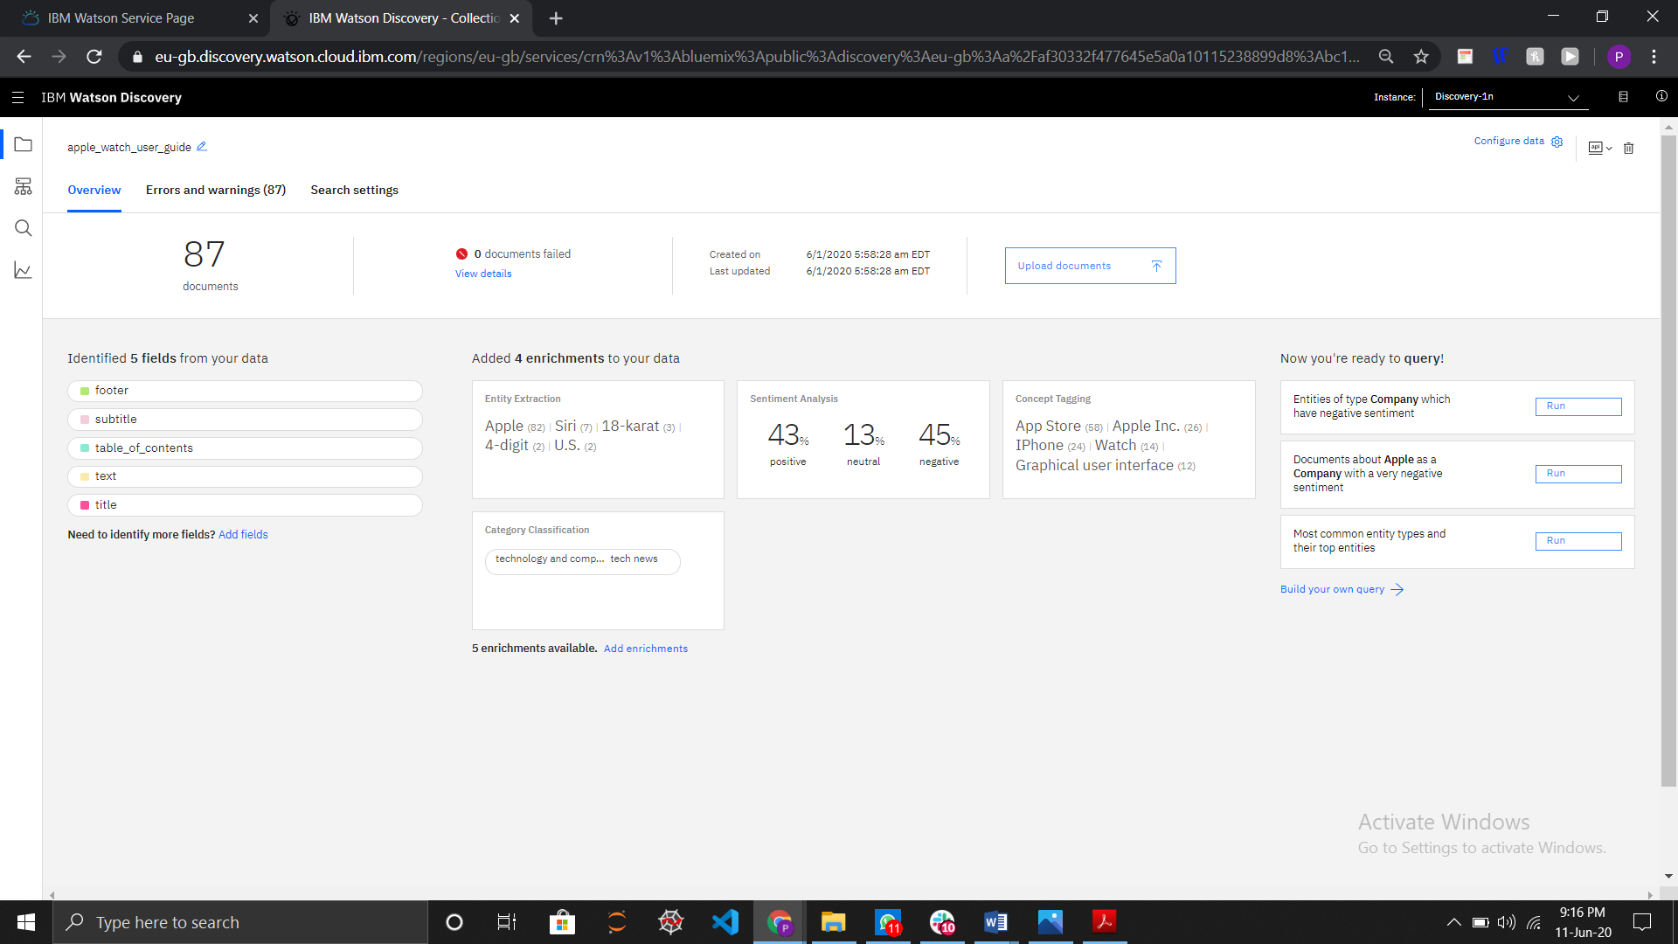

Cloud Function :

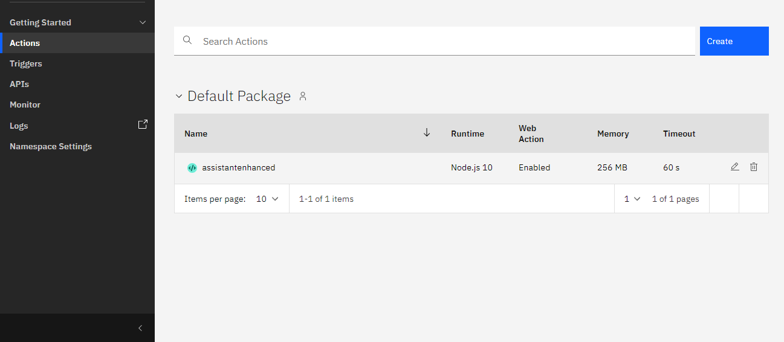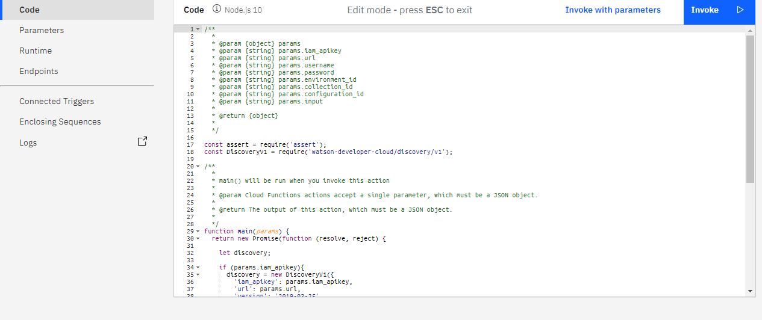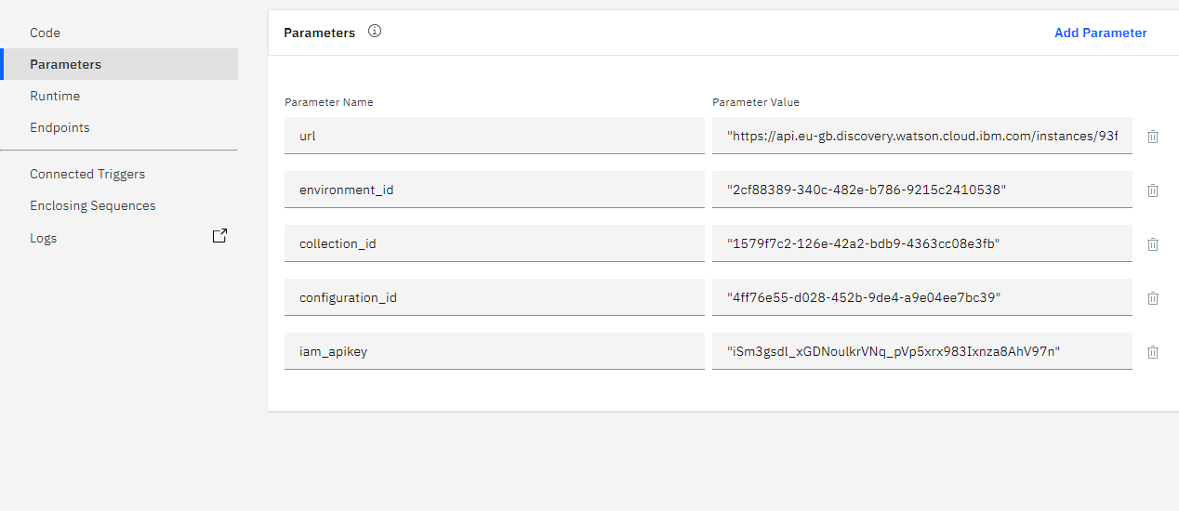

Node-Red :

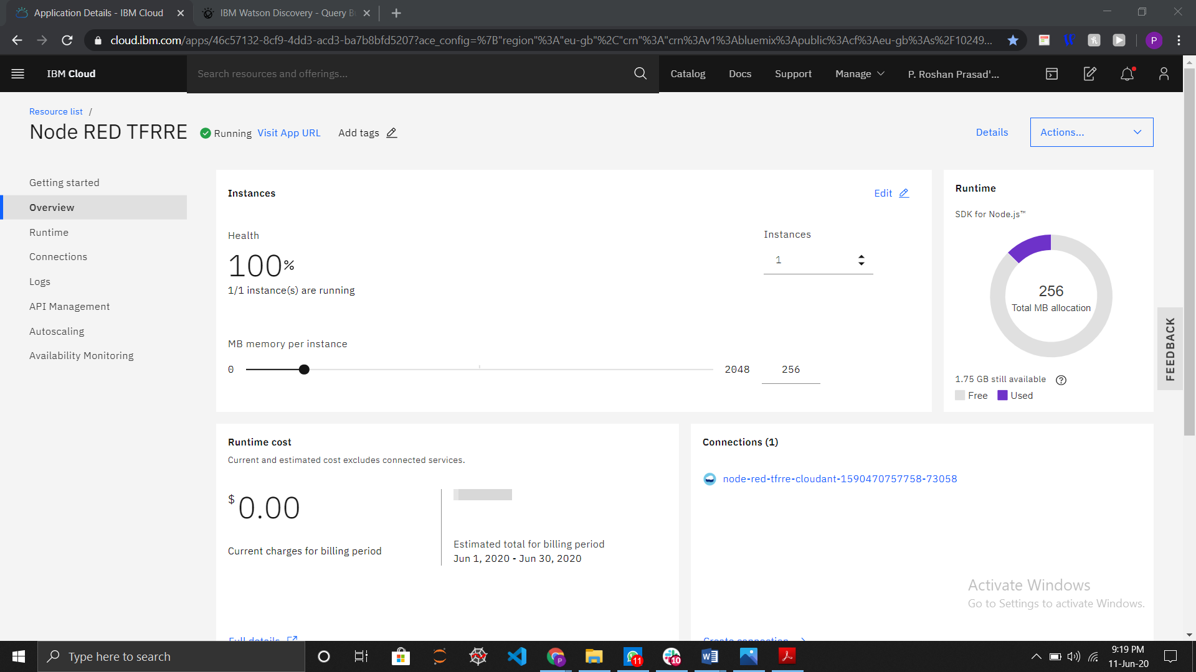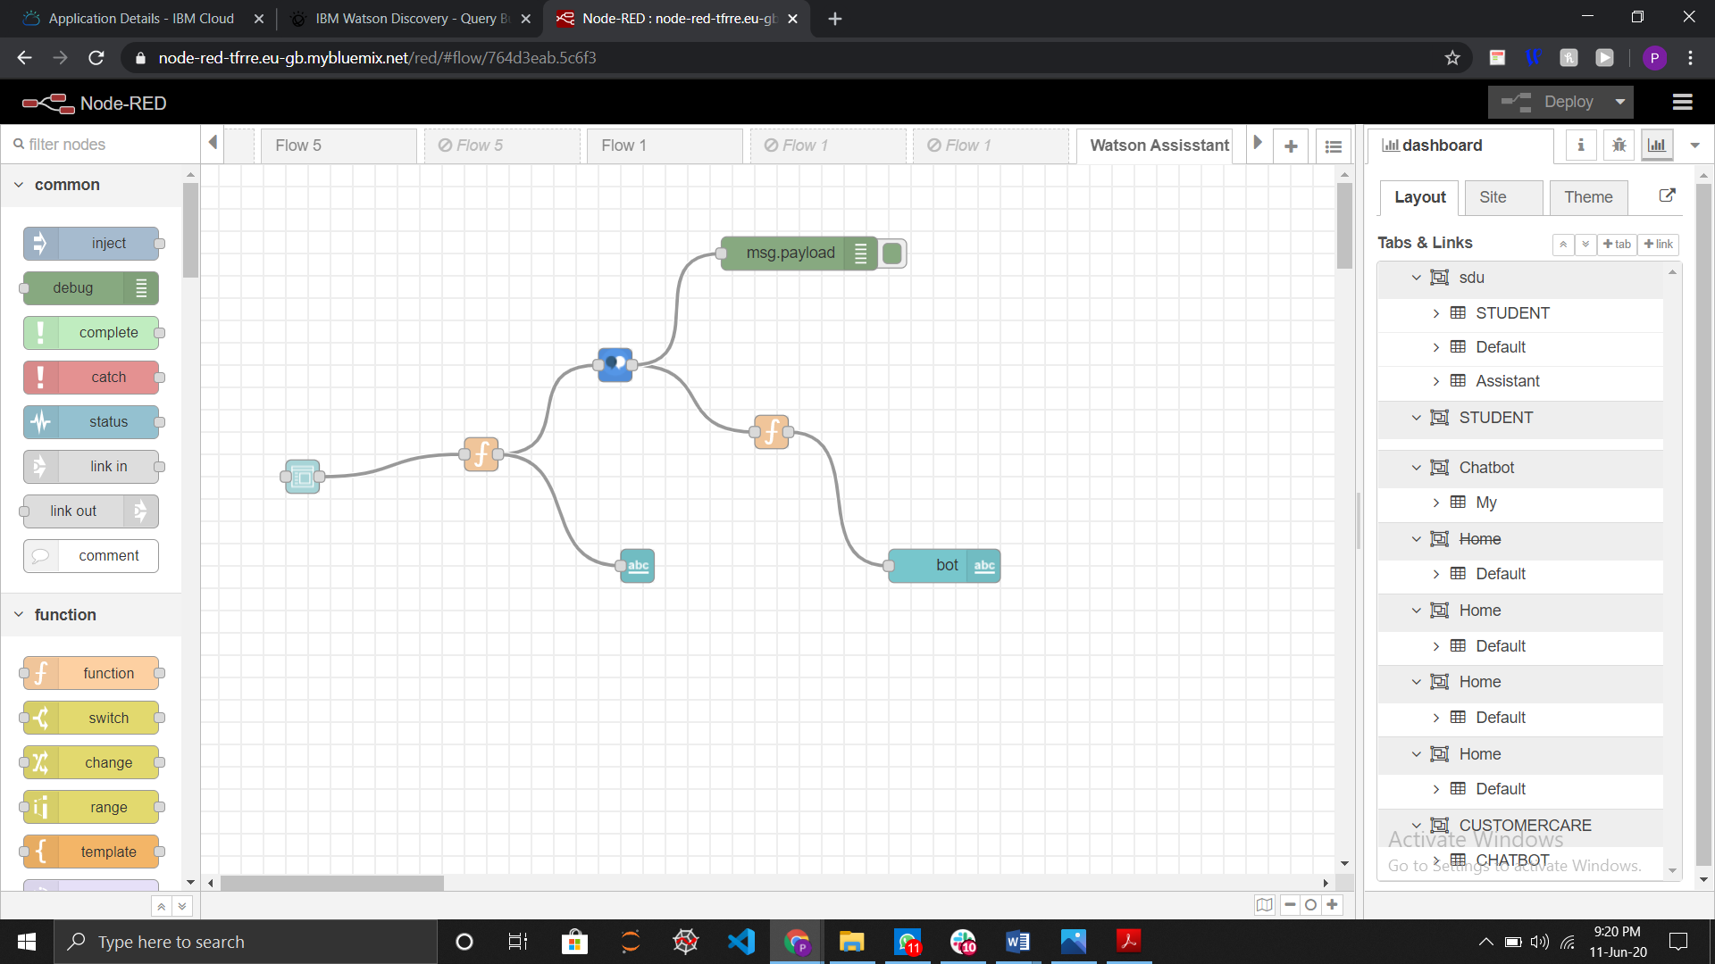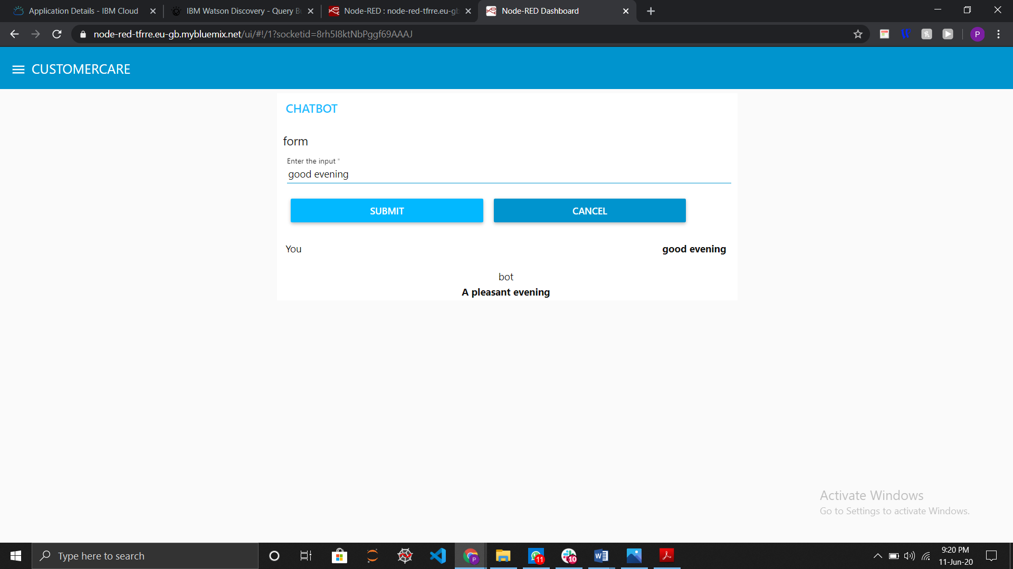

5. Results :

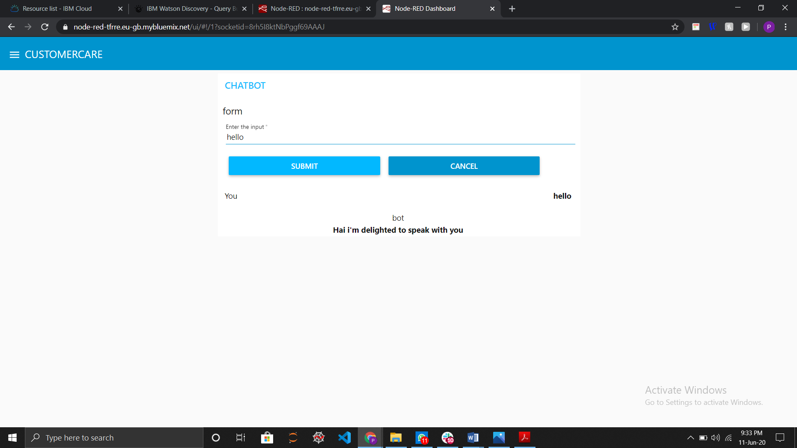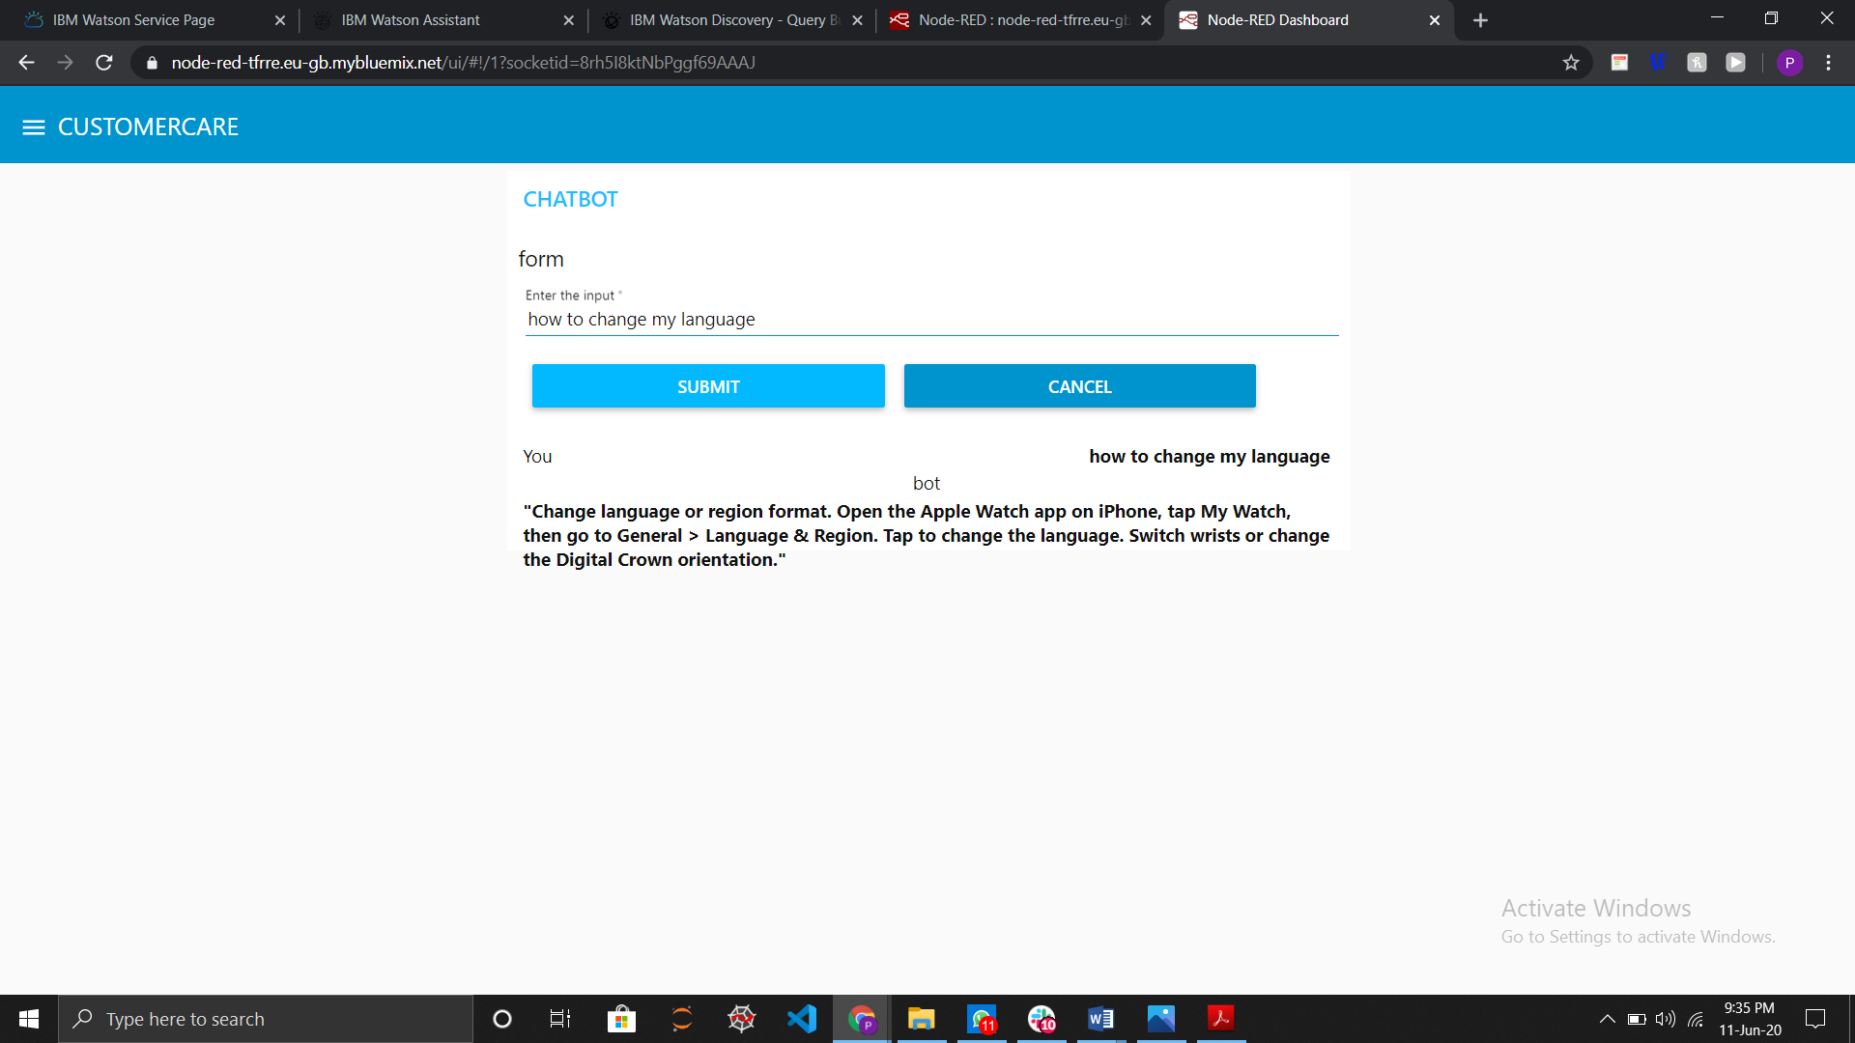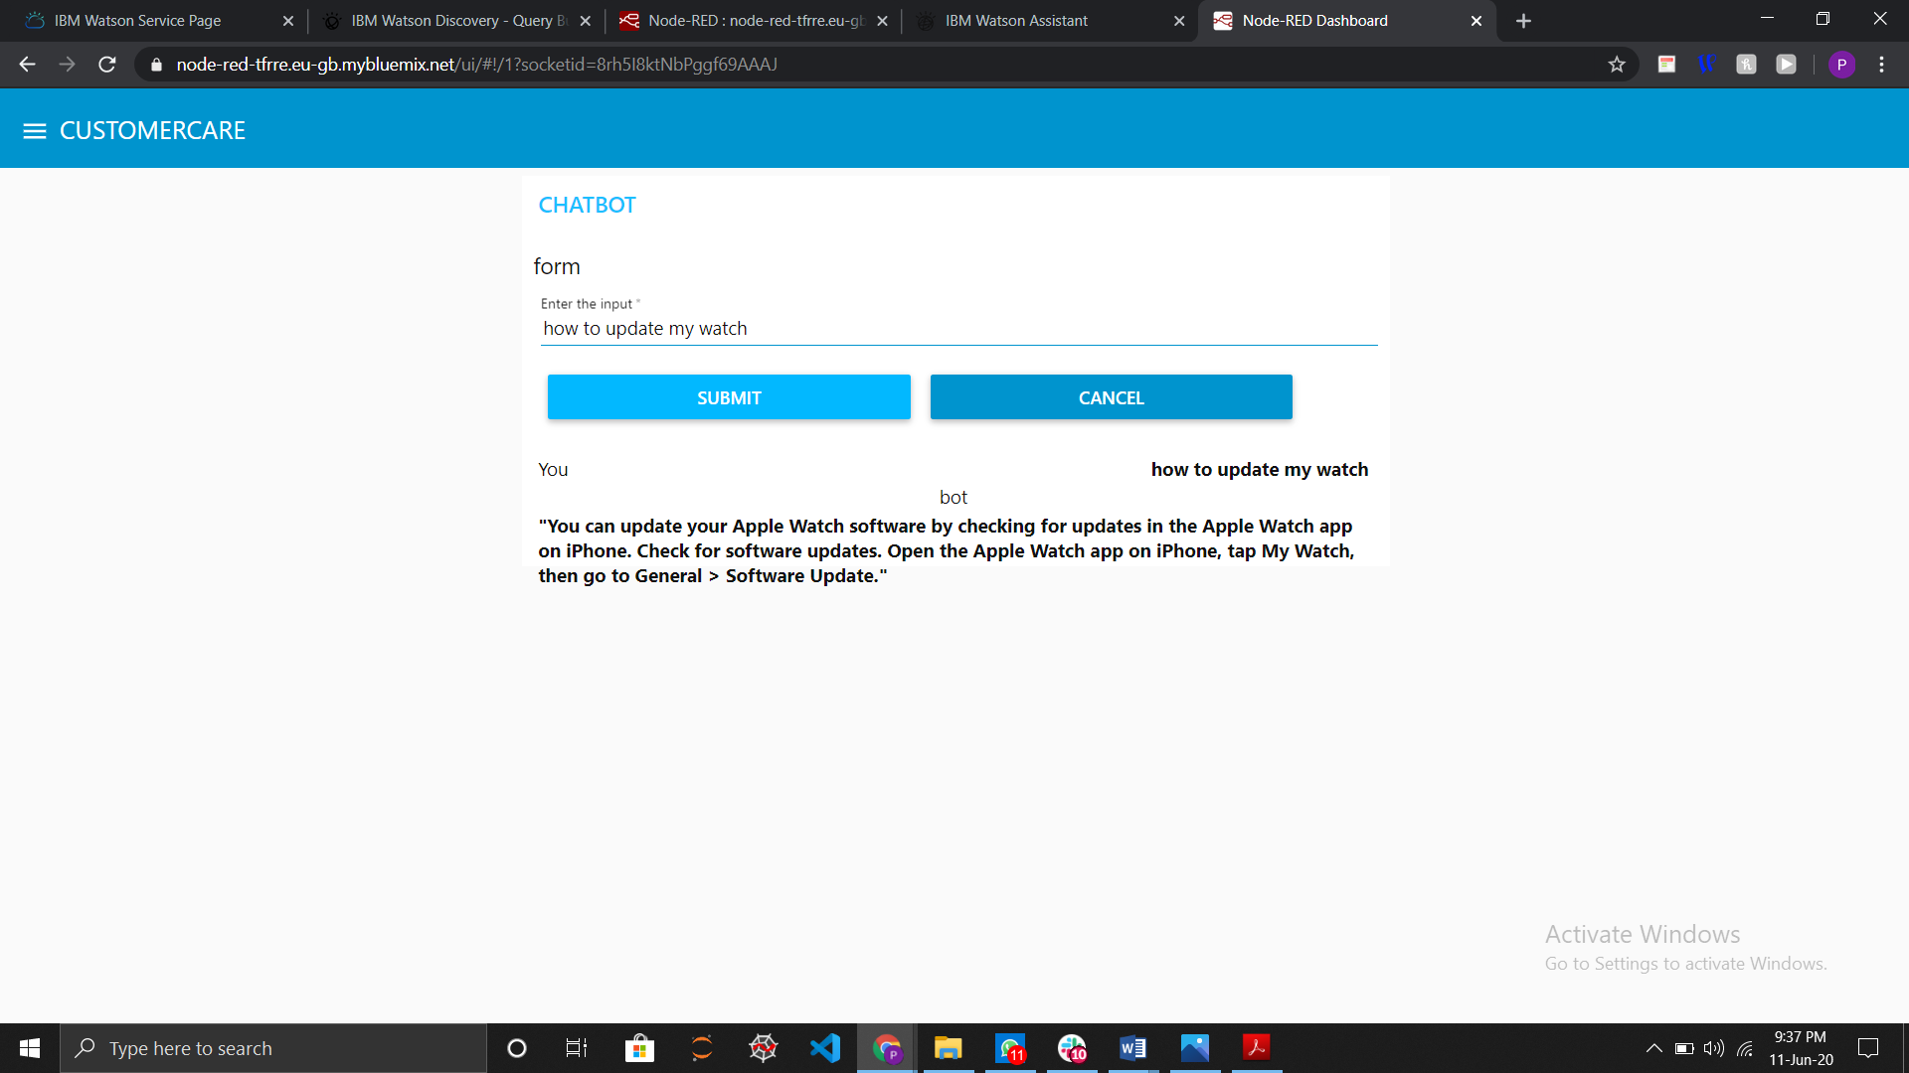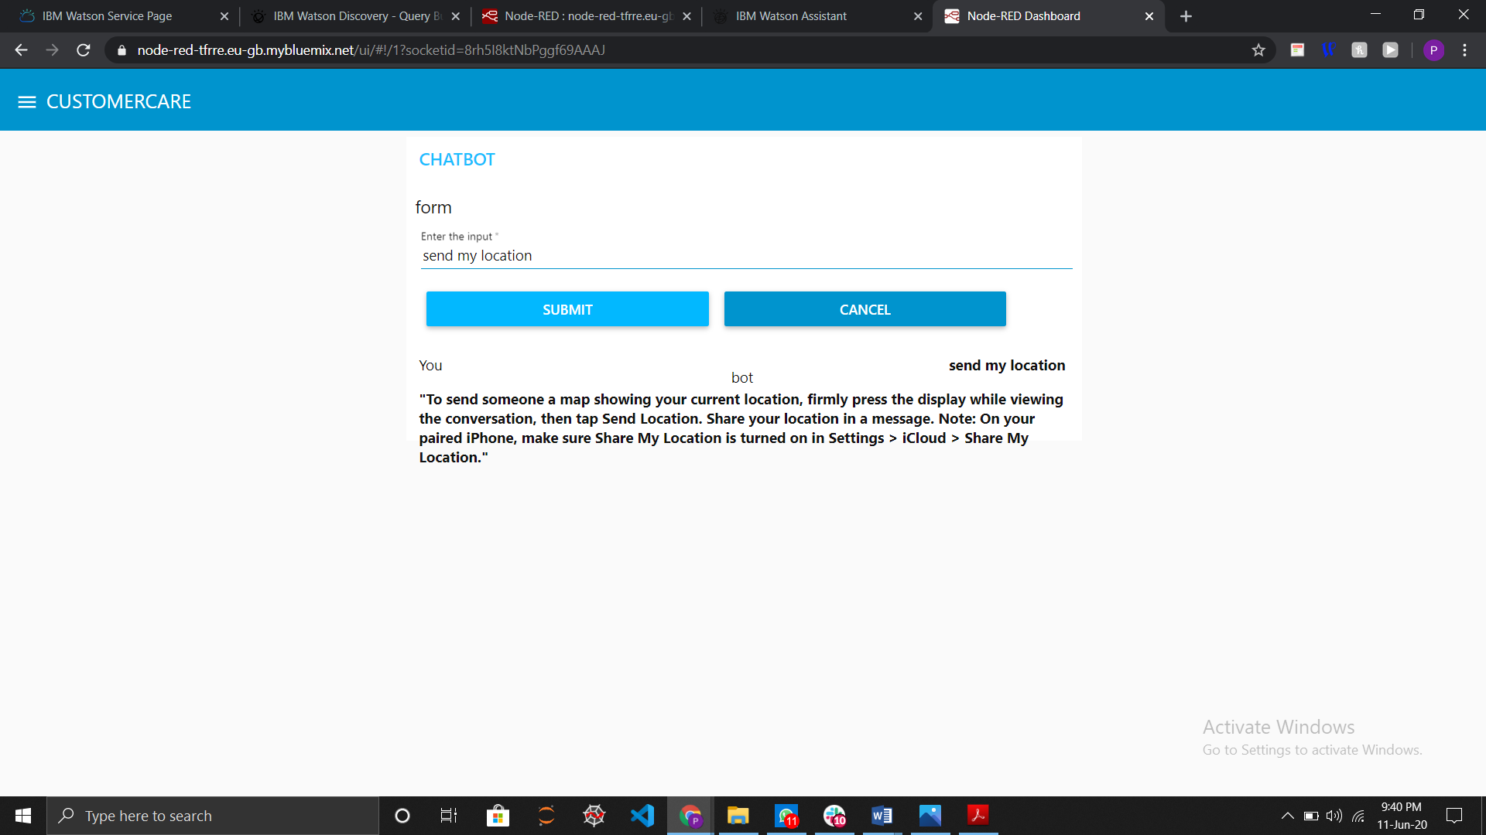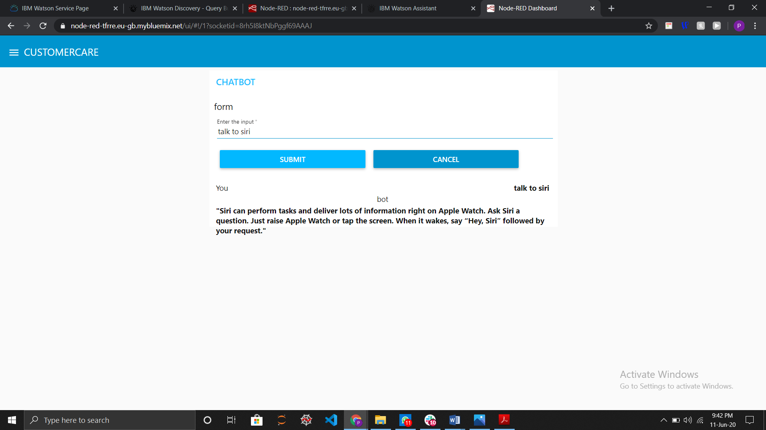

6. Advantages and Disadvantages :

1 . Advantages :

* It automates the repetitive tasks
* It is less expensive
* Increases user interaction
* It can be integrated be in any platform
* Rich analytics and customer interaction
* Instantaneous response without the need for human response delays
* It has an ability like Quick learning and updating
* This chat bot can Management of multiple clients

2. Disadvantages :

* It will take more time for training if we has big dataset or document.
* They have been designed to handle first-level questions only. They may not be able to solve complex queries
* This is not a human which can able to understand the emotions of humans
* To create a efficient chat bot it requires AI concepts and programming knowledge

7. Applications :

* Recruiting : This chat bot can be used to screen the interviewee for the first level. This chat bot can be programmed so that it can ask basic questions like “Do you have any programming experience?”, “What is the A/B testing?”, etc.., so that the bot can rate a person’s performance based on their answers.
* Medical : This chat bot can used as a virtual doctor which can track the symptoms of the user and alerts them when it is emergency. This can also give suggestions based on their suggestions.
* Booking Appointments : Chat bots are smart so, they can also book appointments like Hospitals, meetings, saloons, restaurants, boot camps, etc..,
* Help User : Chat bots can also used as a friend to the user by displaying any information from the web. If any person asks anything to the user, it will search that information and gives accurate output.

8. Conclusion :

Chat bots are becoming smart by improving the performance and user experience. Bots are very essential in the future because most of the companies are implementing in their companies like a virtual customer care – which solves the user queries and assist them.

The next important aspect for the chat bot are feedback and survey through chat bots they strengthen the position of businesses as they analyze the reason behind different levels of customer approval.

They can also make conversations based on the user’s mood like playing music, playing games, etc..,

9. Future Scope :

1 . Voice based control :

The next generation chat bots can be used to control the vehicles by the user’s voice like “park my car”, “open roof top”, etc.., these experiments are in testing now and can be definitely implemented in the future.

2. Emotional Chat bot :

Chat bots are becoming smarter so, we can expect the bots can

Understand the human emotional language and gives response and also recognizes the human voice and perform tasks based on the desire of user. NLP (Natural Language Language) is making tremendous things by improving them.

3. Smart Control :

Smart control in the sense we can control all our surroundings by virtual bots. Like we can unlock the door by saying “open the door.” Integrating the IOT and Chat bots will have a great impact.

10. Biblioography :

<https://cognitiveclass.ai/courses/how-to-build-a-chatbot>

<https://cloud.ibm.com/docs/discovery?topic=discovery-getting-started>

<https://www.youtube.com/watch?v=hitUOFNne14>

<https://cloud.ibm.com/docs/openwhisk?topic=cloud-functions-getting-started>

<https://medium.com/ibm-watson/integrate-watson-assistant-with-just-about-anything-695bc1d29875>

<https://www.youtube.com/watch?v=hitUOFNne14>

<https://randomnerdtutorials.com/getting-started-with-node-red-dashboard/>